**CHR Regional Office 5**

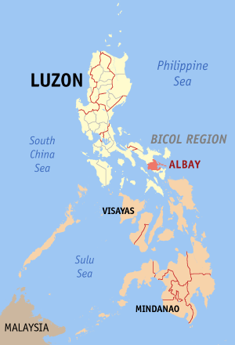

Address : *Government Regional Center*

*Rawis, Legazpi City*

*Albay*

Lot Area : *2,500.00 sq.m.*

Floor Area : *487,00 sq.m (1-storey building)*

Amount : *Php14,000,000.00*

Date Started : *June 16, 2015*

Date Completed : *February 2016*

*Date Inaugurated : March 8, 2016*

***The newly built CHR Region 5 Office:***

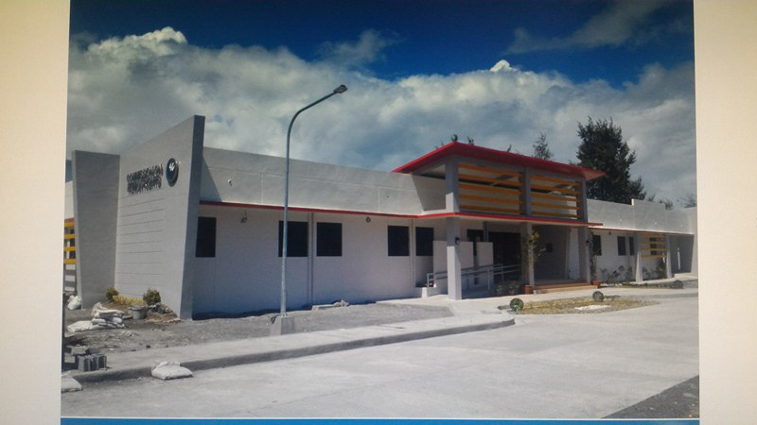

***Inauguration:***

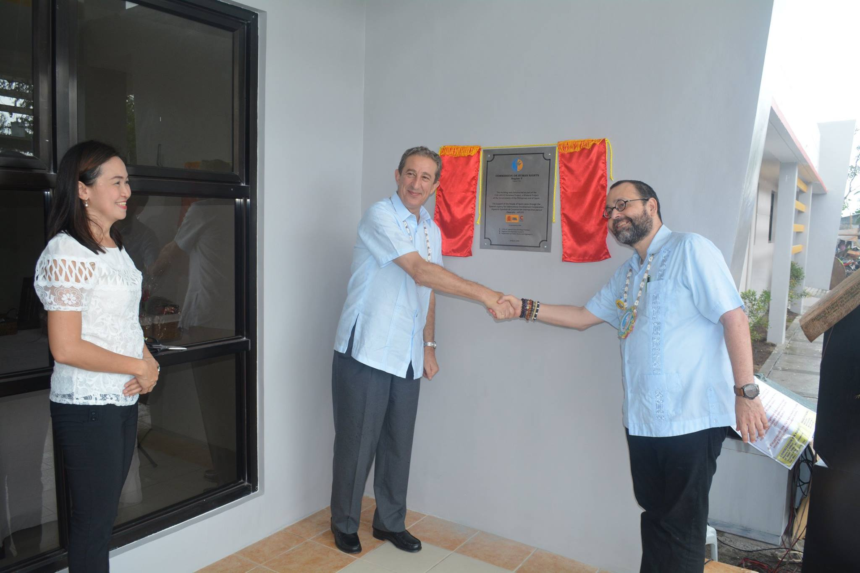

***Groundbreaking Ceremony:***

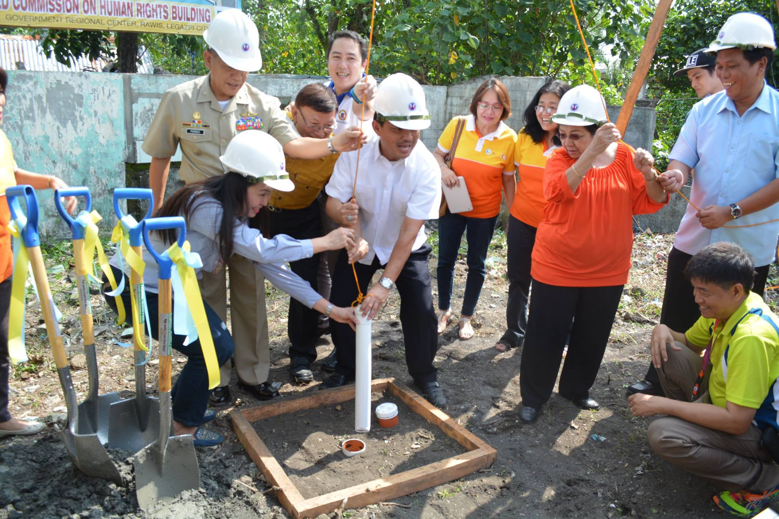

***Signed MOA with DPWH Region 5:***

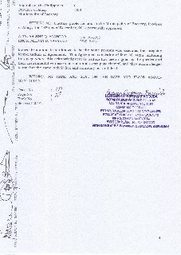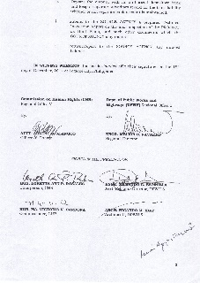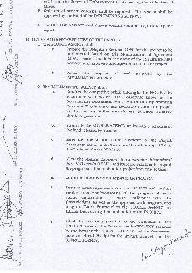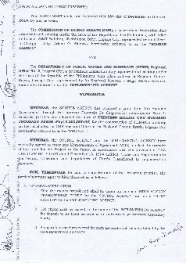

***CHR Region 5 Office BEFORE:*** *ANST Building, Washington Drive*

*Legazpi City, Albay*

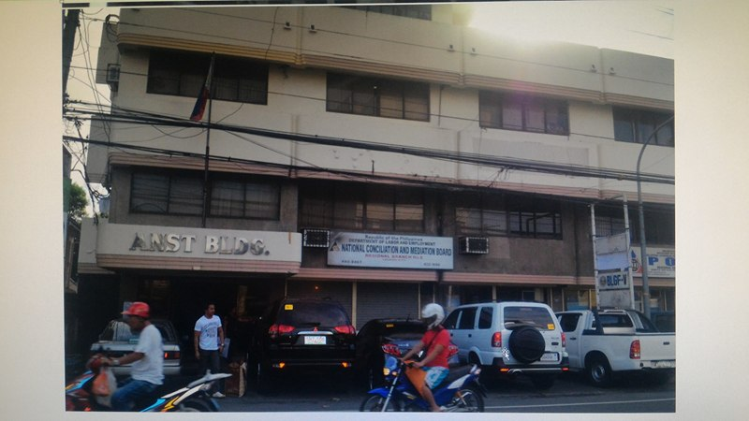

***Certificate of Land Allocation to CHR 5:***

